Treball de Fi de Màster

**Màster Universitari en Enginyeria d’Organització**

**Detecció de defectes en cel·les fotovoltaiques sobre imatges obtingudes via electroluminescència mitjançant xarxes neuronals convolucionals (CNN)**

ANNEXOS

**Autor:** Marc Campmany Garcia

**Director:**  Joan Ferran Salaet Pereira

**Convocatòria:** Juny 2021





# Exemple derivada parcial Backpropagation

For simplicity, let’s pretend we only have Alice in our dataset:

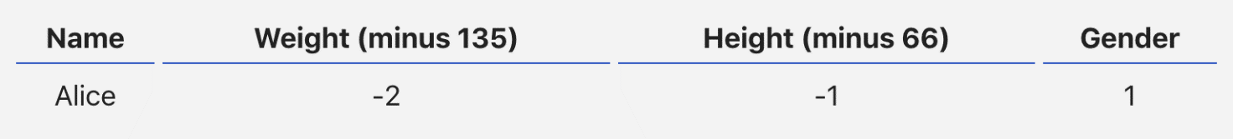

Then the mean squared error loss is just Alice’s squared error:



Another way to think about loss is as a function of weights and biases. Let’s label each weight and bias in our network:

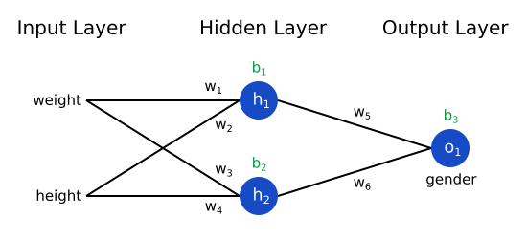

Then, we can write loss as a multivariable function:



Imagine we wanted to tweak w1​. How would loss L change if we changed w1​? That’s a question the partial derivative can answer. How do we calculate it?

To start, let’s rewrite the partial derivative in terms of ∂y_pred/∂w1​​ instead:



This works because of the Chain Rule.

We can calculate ∂L/∂y_pred​ because we computed L= (1−y_pred​)² above:



Now, let’s figure out what to do with ∂y_pred/∂w1. Just like before, let h1​, h2​, o1​ be the outputs of the neurons they represent. Then



f is the sigmoid activation function, remember?

Since w1​ only affects h1​ (not h2​), we can write



We do the same thing for ∂h1​​/∂w1:



x1​ here is weight, and x2​ is height. This is the second time we’ve seen f′(x) (the derivate of the sigmoid function) now! Let’s derive it:



We’ll use this nice form for f′(x) later.

We’re done! We’ve managed to break down ∂L/∂w1​ into several parts we can calculate:



This system of calculating partial derivatives by working backwards is known as backpropagation, or “backprop”.

# Class Imbalance

## Model amb Data augmentation

|  |  |  |  |  |  |
| --- | --- | --- | --- | --- | --- |
|  | Loss | Accuracy | Precision | Recall | AUC |
| Train | 0.8381 | 0.8489 | 0.7291 | 0.6295 | 0.8780 |
| Val. | 0.8869 | 0.8445 | 0.7005 | 0.6603 | 0.8660 |
| Test | 0.8266 | 0.8486 | 0.7125 | 0.6610 | 0.8825 |

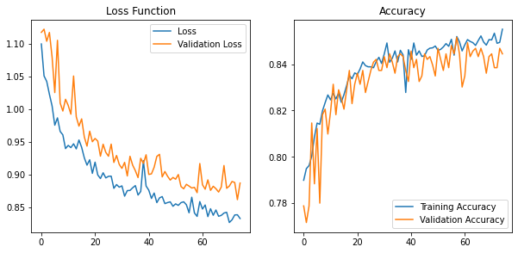

Confusion Matrix

[[109 0 0 2]

[ 25 0 0 0]

[ 12 0 0 1]

[ 28 0 0 32]]

Classification Report

precision recall f1-score support

0.0 0.63 0.98 0.76 111

0.33 0.00 0.00 0.00 25

0.66 0.00 0.00 0.00 13

1.0 0.91 0.53 0.67 60

accuracy 0.67 209

macro avg 0.39 0.38 0.36 209

weighted avg 0.60 0.67 0.60 209

## Model amb Equilibri de pesos

|  |  |  |  |  |  |
| --- | --- | --- | --- | --- | --- |
|  | Loss | Accuracy | Precision | Recall | AUC |
| Train | 0.7328 | 0.9147 | 0.8712 | 0.7729 | 0.9654 |
| Val. | 1.0824 | 0.8242 | 0.6632 | 0.6029 | 0.8660 |
| Test | 1.0310 | 0.8476 | 0.7167 | 0.6457 | 0.8752 |

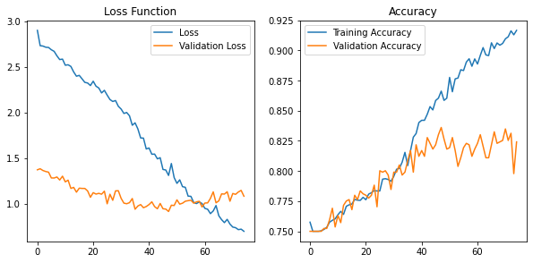

Confusion Matrix

[[76 18 2 15]

[ 8 13 2 2]

[ 6 1 4 2]

[15 3 3 39]]

Classification Report

precision recall f1-score support

0.0 0.72 0.68 0.70 111

0.33 0.37 0.52 0.43 25

0.66 0.36 0.31 0.33 13

1.0 0.67 0.65 0.66 60

accuracy 0.63 209

macro avg 0.53 0.54 0.53 209

weighted avg 0.64 0.63 0.64 209

## Model amb Transfer Learning

|  |  |  |  |  |  |
| --- | --- | --- | --- | --- | --- |
|  | Loss | Accuracy | Precision | Recall | AUC |
| Train | 0.1543 | 0.9795 | 0.9695 | 0.9479 | 0.9974 |
| Val. | 0.8685 | 0.8529 | 0.7150 | 0.6842 | 0.9039 |
| Test | 0.7546 | 0.8650 | 0.7413 | 0.7065 | 0.9111 |

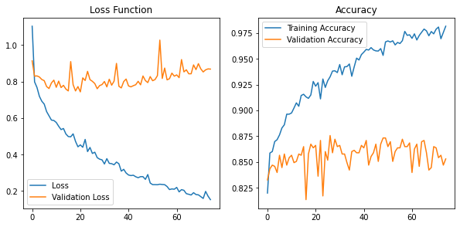

Confusion Matrix

[[99 3 0 9]

[17 7 0 1]

[ 7 1 1 4]

[16 2 3 39]]

Classification Report

precision recall f1-score support

0.0 0.71 0.89 0.79 111

0.33 0.54 0.28 0.37 25

0.66 0.25 0.08 0.12 13

1.0 0.74 0.65 0.69 60

accuracy 0.70 209

macro avg 0.56 0.47 0.49 209

weighted avg 0.67 0.70 0.67 209

## Model amb Oversampling

|  |  |  |  |  |  |
| --- | --- | --- | --- | --- | --- |
|  | Loss | Accuracy | Precision | Recall | AUC |
| Train | 0.7336 | 0.8517 | 0.7947 | 0.5498 | 0.9066 |
| Val. | 1.9222 | 0.7312 | 0.4444 | 0.3011 | 0.6628 |
| Test | 0.9942 | 0.8495 | 0.7590 | 0.5833 | 0.8531 |

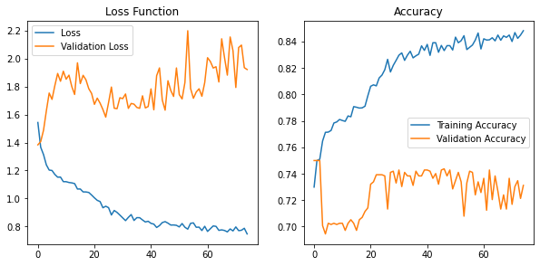

Confusion Matrix

[[49 6 0 33]

[39 7 0 22]

[27 4 0 18]

[39 3 0 32]]

Classification Report

precision recall f1-score support

0.0 0.32 0.56 0.40 88

0.33 0.35 0.10 0.16 68

0.66 0.00 0.00 0.00 49

1.0 0.30 0.43 0.36 74

accuracy 0.32 279

macro avg 0.24 0.27 0.23 279

weighted avg 0.27 0.32 0.26 279

# Models amb millores

## Tipus mono, pesos, L2 i early stop

|  |  |  |  |  |  |
| --- | --- | --- | --- | --- | --- |
|  | Loss | Accuracy | Precision | Recall | AUC |
| Train | 0.0897 | 0.0101 | 0.9863 | 0.9836 | 0.9996 |
| Val. | 1.4930 | 0.0087 | 0.6715 | 0.6389 | 0.8638 |
| Test | 0.7690 | 0.00 | 0.8485 | 0.7778 | 0.9175 |

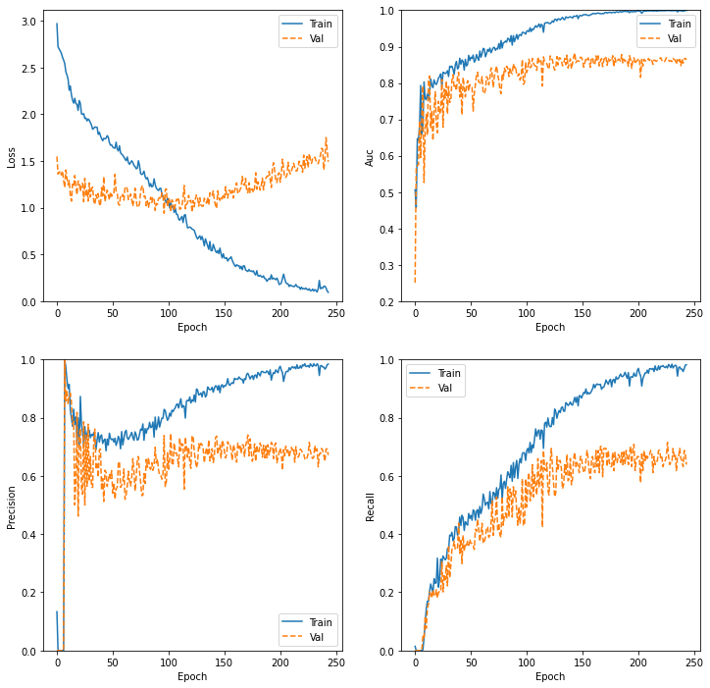

Confusion Matrix

[[58 2 3 4]

[ 2 6 3 1]

[ 2 0 2 2]

[ 3 0 0 20]]

Classification Report

precision recall f1-score support

0.0 0.89 0.87 0.88 67

0.33 0.75 0.50 0.60 12

0.66 0.25 0.33 0.29 6

1.0 0.74 0.87 0.80 23

accuracy 0.80 108

macro avg 0.66 0.64 0.64 108

weighted avg 0.81 0.80 0.80 108

## Tipus mono, pesos, data augmentation, L2, early stop

|  |  |  |  |  |  |
| --- | --- | --- | --- | --- | --- |
|  | Loss | Accuracy | Precision | Recall | AUC |
| Train | 2.0121 | 0.0 | 0.7647 | 0.3845 | 0.8128 |
| Val. | 1.1800 | 0.0 | 0.7097 | 0.3056 | 0.7786 |
| Test | 0.9754 | 0.0 | 0.7931 | 0.4259 | 0.8375 |

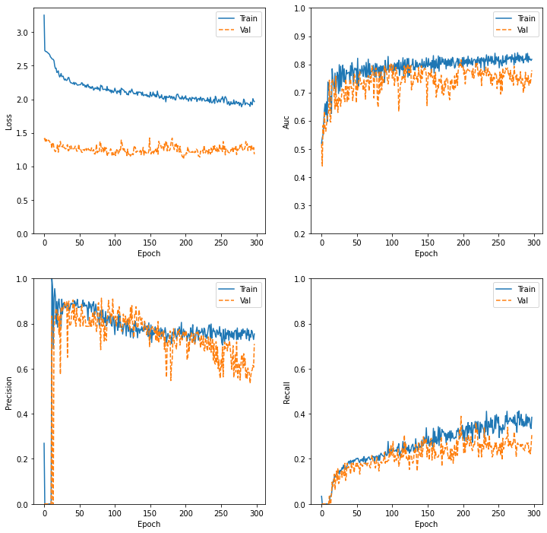

Confusion Matrix

[[46 9 8 4]

[ 5 7 0 0]

[ 2 1 2 1]

[ 5 0 2 16]]

Classification Report

precision recall f1-score support

0.0 0.79 0.69 0.74 67

0.33 0.41 0.58 0.48 12

0.66 0.17 0.33 0.22 6

1.0 0.76 0.70 0.73 23

accuracy 0.66 108

macro avg 0.53 0.57 0.54 108

weighted avg 0.71 0.66 0.68 108

## Tipus mono, transfer learning, data aug, L2, early stop

|  |  |  |  |  |  |
| --- | --- | --- | --- | --- | --- |
|  | Loss | Accuracy | Precision | Recall | AUC |
| Train | 0.5654 | 0.0120 | 0.8201 | 0.7549 | 0.9467 |
| Val. | 0.9328 | 0.0122 | 0.7692 | 0.6944 | 0.8879 |
| Test | 0.6434 | 0.0093 | 0.8000 | 0.7778 | 0.9361 |

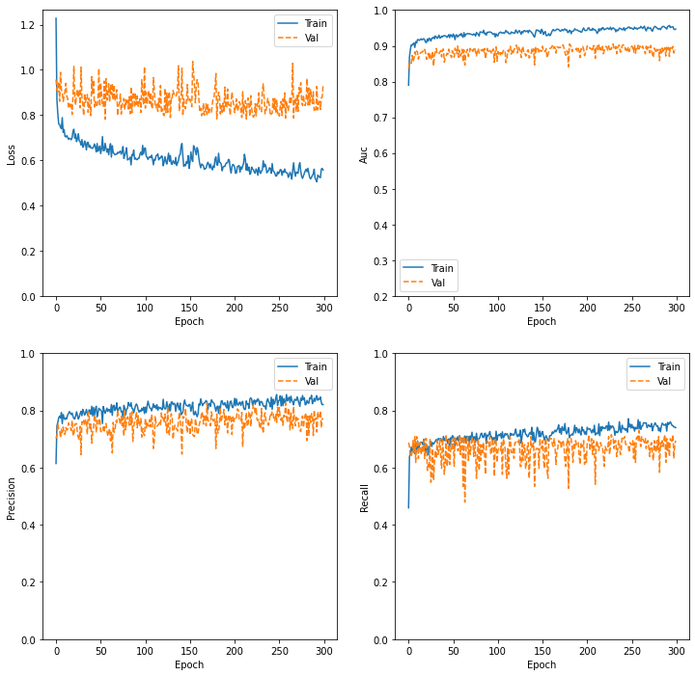

Confusion Matrix

[[64 1 0 2]

[ 8 4 0 0]

[ 5 1 0 0]

[ 5 0 0 18]]

Classification Report

precision recall f1-score support

0.0 0.78 0.96 0.86 67

0.33 0.67 0.33 0.44 12

0.66 0.00 0.00 0.00 6

1.0 0.90 0.78 0.84 23

accuracy 0.80 108

macro avg 0.59 0.52 0.54 108

weighted avg 0.75 0.80 0.76 108

## Tipus mono, pesos, transfer learning, L2, early stop

|  |  |  |  |  |  |
| --- | --- | --- | --- | --- | --- |
|  | Loss | Accuracy | Precision | Recall | AUC |
| Train | 0.2762 | 0.0152 | 0.9711 | 0.9543 | 0.9981 |
| Val. | 1.0397 | 0.0122 | 0.7153 | 0.6806 | 0.8730 |
| Test | 0.5998 | 0.000 | 0.8229 | 0.7315 | 0.9401 |

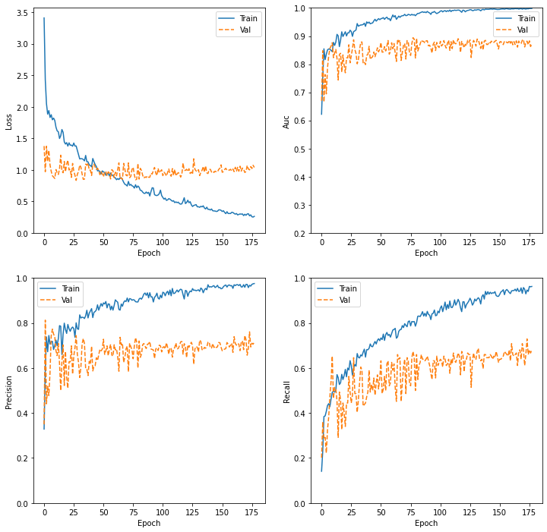

Confusion Matrix

[[60 3 2 2]

[ 5 6 1 0]

[ 3 1 2 0]

[ 7 0 0 16]]

Classification Report

precision recall f1-score support

0.0 0.80 0.90 0.85 67

0.33 0.60 0.50 0.55 12

0.66 0.40 0.33 0.36 6

1.0 0.89 0.70 0.78 23

accuracy 0.78 108

macro avg 0.67 0.61 0.63 108

weighted avg 0.77 0.78 0.77 108

## Tipus mono, pesos, transfer learning, L2, early stop, data aug

|  |  |  |  |  |  |
| --- | --- | --- | --- | --- | --- |
|  | Loss | Accuracy | Precision | Recall | AUC |
| Train | 1.4723 |  | 0.7482 | 0.5397 | 0.8975 |
| Val. | 0.9978 |  | 0.6195 | 0.4861 | 0.8350 |
| Test | 0.7945 |  | 0.7294 | 0.5741 | 0.8900 |

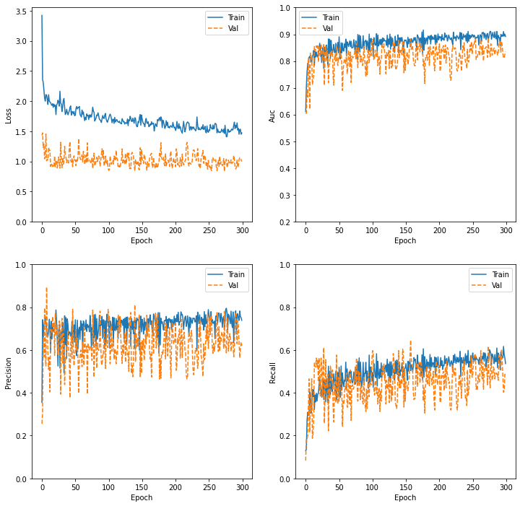

Confusion Matrix

[[43 15 4 5]

[ 1 8 2 1]

[ 2 3 1 0]

[ 2 1 1 19]]

Classification Report

precision recall f1-score support

0.0 0.90 0.64 0.75 67

0.33 0.30 0.67 0.41 12

0.66 0.12 0.17 0.14 6

1.0 0.76 0.83 0.79 23

accuracy 0.66 108

macro avg 0.52 0.58 0.52 108

weighted avg 0.76 0.66 0.69 108

## Tipus mono, 4-capes convolucionals, pesos, L2, early stop

|  |  |  |  |  |  |
| --- | --- | --- | --- | --- | --- |
|  | Loss | Accuracy | Precision | Recall | AUC |
| Train | 0.4264 |  | 0.9210 | 0.9009 | 0.9878 |
| Val. | 1.5022 |  | 0.6809 | 0.6667 | 0.8441 |
| Test | 0.8887 |  | 0.7708 | 0.6852 | 0.9015 |

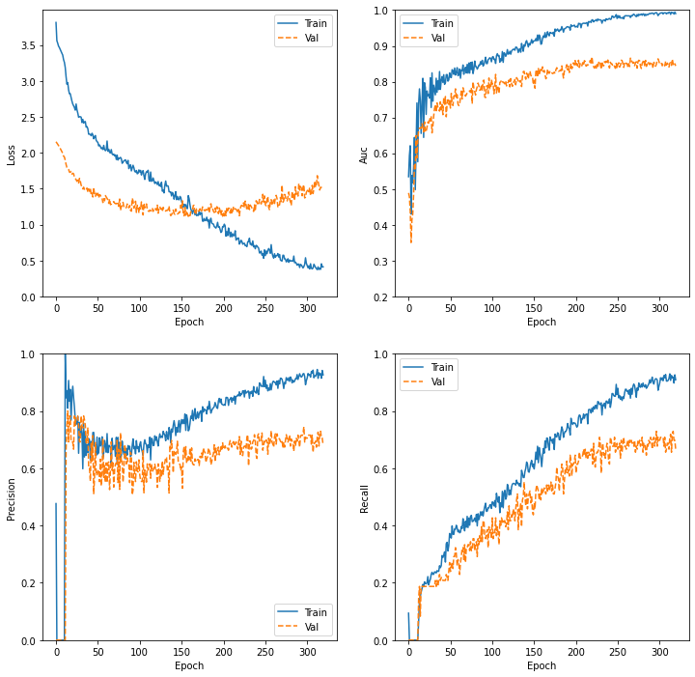

Confusion Matrix

[[54 3 5 5]

[ 2 7 3 0]

[ 2 0 1 3]

[ 4 0 0 19]]

Classification Report

precision recall f1-score support

0.0 0.87 0.81 0.84 67

0.33 0.70 0.58 0.64 12

0.66 0.11 0.17 0.13 6

1.0 0.70 0.83 0.76 23

accuracy 0.75 108

macro avg 0.60 0.60 0.59 108

weighted avg 0.77 0.75 0.76 108

# Models amb validació creuada

## K-FOLDS 3-capes mono

14819 segons =4.1 hores

### FOLD-1

Confusion Matrix

[[43 9 4 3]

[ 3 5 2 1]

[ 1 2 3 0]

[10 2 2 18]]

Classification Report

precision recall f1-score support

0.0 0.75 0.73 0.74 59

0.33 0.28 0.45 0.34 11

0.66 0.27 0.50 0.35 6

1.0 0.82 0.56 0.67 32

accuracy 0.64 108

macro avg 0.53 0.56 0.53 108

weighted avg 0.70 0.64 0.66 108

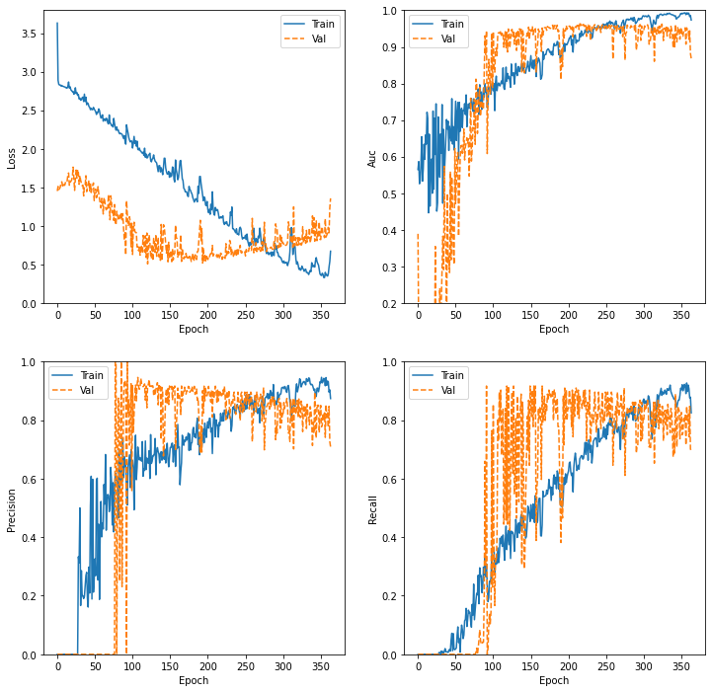

### FOLD-2

Confusion Matrix

[[42 4 4 8]

[ 3 7 2 0]

[ 1 0 4 1]

[ 7 2 2 21]]

Classification Report

precision recall f1-score support

0.0 0.79 0.72 0.76 58

0.33 0.54 0.58 0.56 12

0.66 0.33 0.67 0.44 6

1.0 0.70 0.66 0.68 32

accuracy 0.69 108

macro avg 0.59 0.66 0.61 108

weighted avg 0.71 0.69 0.69 108

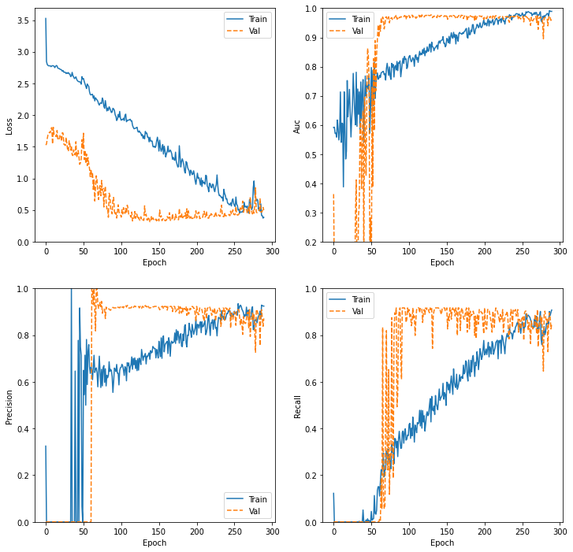

### FOLD-3

Confusion Matrix

[[47 2 1 8]

[ 1 7 2 2]

[ 2 0 2 2]

[ 5 2 1 24]]

Classification Report

precision recall f1-score support

0.0 0.85 0.81 0.83 58

0.33 0.64 0.58 0.61 12

0.66 0.33 0.33 0.33 6

1.0 0.67 0.75 0.71 32

accuracy 0.74 108

macro avg 0.62 0.62 0.62 108

weighted avg 0.75 0.74 0.74 108

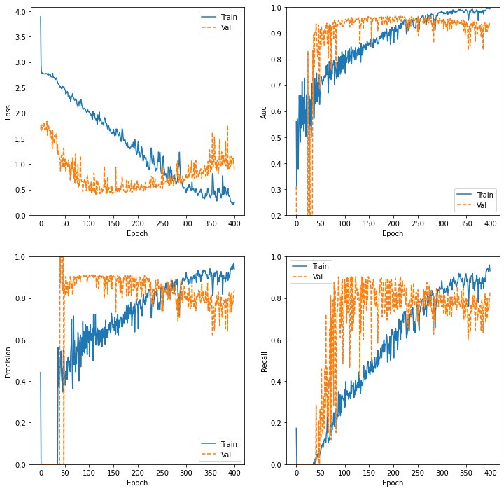

### FOLD-4

Confusion Matrix

[[37 10 2 10]

[ 3 8 0 1]

[ 4 0 1 1]

[ 3 0 4 24]]

Classification Report

precision recall f1-score support

0.0 0.79 0.63 0.70 59

0.33 0.44 0.67 0.53 12

0.66 0.14 0.17 0.15 6

1.0 0.67 0.77 0.72 31

accuracy 0.65 108

macro avg 0.51 0.56 0.53 108

weighted avg 0.68 0.65 0.65 108

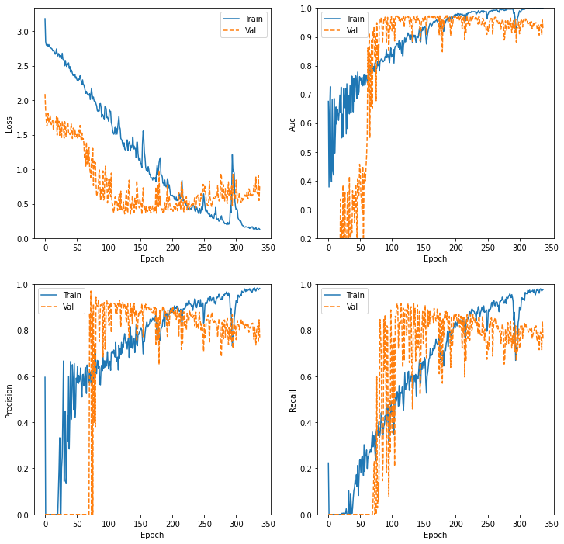

### FOLD-5

Confusion Matrix

[[49 7 0 3]

[ 5 7 0 0]

[ 2 3 0 0]

[ 5 3 1 22]]

Classification Report

precision recall f1-score support

0.0 0.80 0.83 0.82 59

0.33 0.35 0.58 0.44 12

0.66 0.00 0.00 0.00 5

1.0 0.88 0.71 0.79 31

accuracy 0.73 107

macro avg 0.51 0.53 0.51 107

weighted avg 0.74 0.73 0.73 107

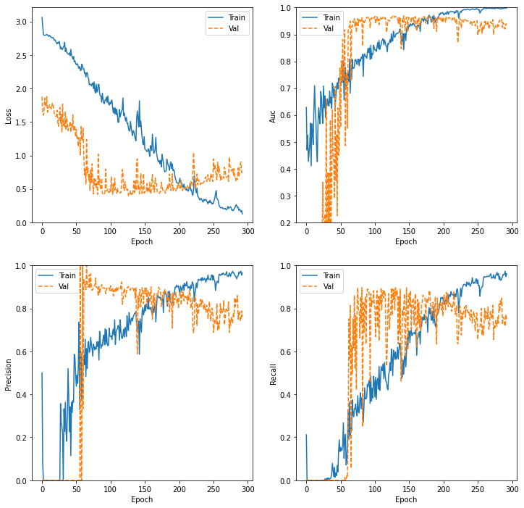

### FOLD-6

Confusion Matrix

[[38 6 5 10]

[ 2 8 2 0]

[ 0 2 3 0]

[ 3 1 3 24]]

Classification Report

precision recall f1-score support

0.0 0.88 0.64 0.75 59

0.33 0.47 0.67 0.55 12

0.66 0.23 0.60 0.33 5

1.0 0.71 0.77 0.74 31

accuracy 0.68 107

macro avg 0.57 0.67 0.59 107

weighted avg 0.76 0.68 0.70 107

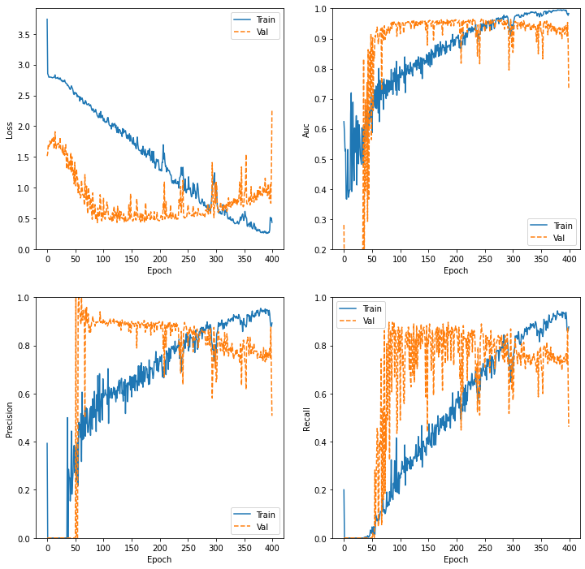

### FOLD-7

Confusion Matrix

[[38 6 5 10]

[ 2 8 2 0]

[ 0 2 3 0]

[ 3 1 3 24]]

Classification Report

precision recall f1-score support

0.0 0.88 0.64 0.75 59

0.33 0.47 0.67 0.55 12

0.66 0.23 0.60 0.33 5

1.0 0.71 0.77 0.74 31

accuracy 0.68 107

macro avg 0.57 0.67 0.59 107

weighted avg 0.76 0.68 0.70 107

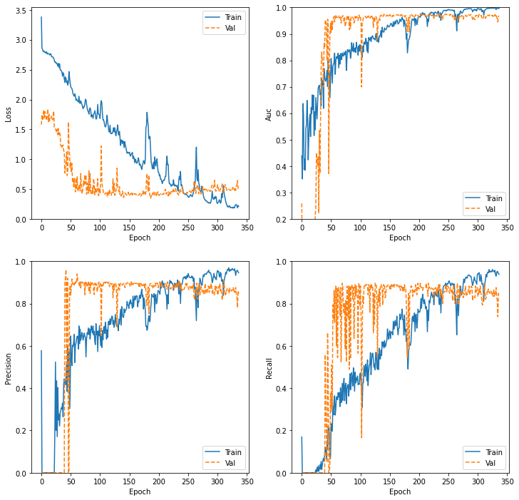

### FOLD-8

Confusion Matrix

[[40 3 5 11]

[ 4 5 1 2]

[ 1 0 2 2]

[ 1 0 0 30]]

Classification Report

precision recall f1-score support

0.0 0.87 0.68 0.76 59

0.33 0.62 0.42 0.50 12

0.66 0.25 0.40 0.31 5

1.0 0.67 0.97 0.79 31

accuracy 0.72 107

macro avg 0.60 0.62 0.59 107

weighted avg 0.75 0.72 0.72 107

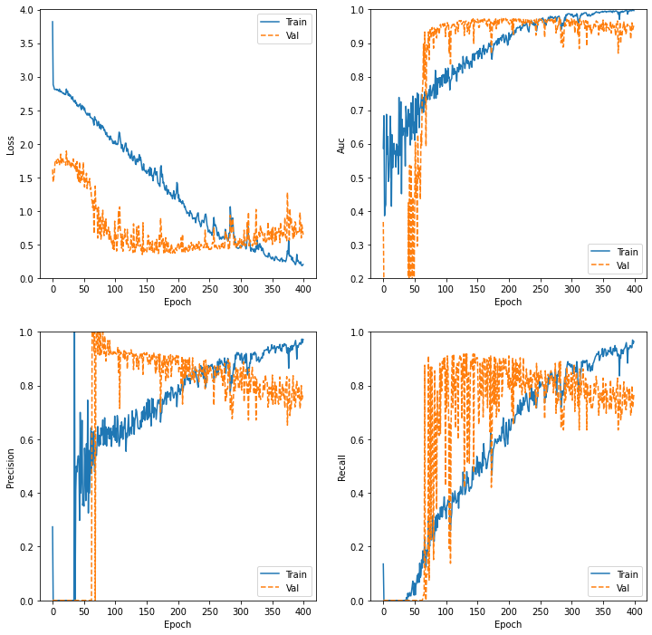

### FOLD-9

Confusion Matrix

[[53 1 3 2]

[ 5 4 1 1]

[ 4 0 0 2]

[ 5 0 1 25]]

Classification Report

precision recall f1-score support

0.0 0.79 0.90 0.84 59

0.33 0.80 0.36 0.50 11

0.66 0.00 0.00 0.00 6

1.0 0.83 0.81 0.82 31

accuracy 0.77 107

macro avg 0.61 0.52 0.54 107

weighted avg 0.76 0.77 0.75 107

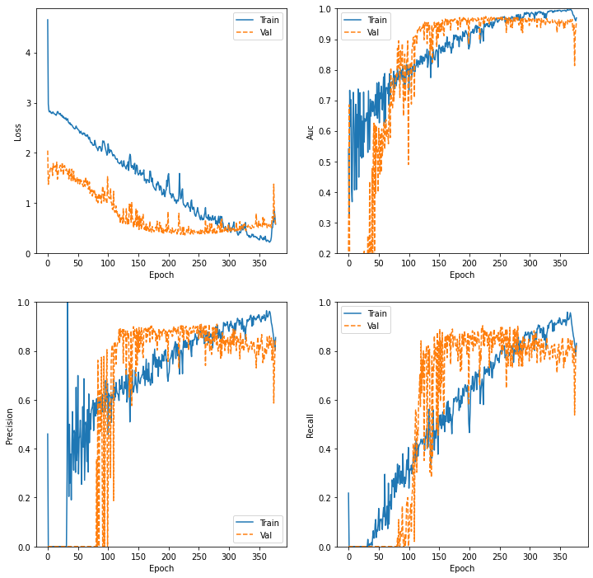

### FOLD-10

Confusion Matrix

[[25 7 5 22]

[ 2 4 2 3]

[ 0 1 3 2]

[ 1 1 2 27]]

Classification Report

precision recall f1-score support

0.0 0.89 0.42 0.57 59

0.33 0.31 0.36 0.33 11

0.66 0.25 0.50 0.33 6

1.0 0.50 0.87 0.64 31

accuracy 0.55 107

macro avg 0.49 0.54 0.47 107

weighted avg 0.68 0.55 0.55 107

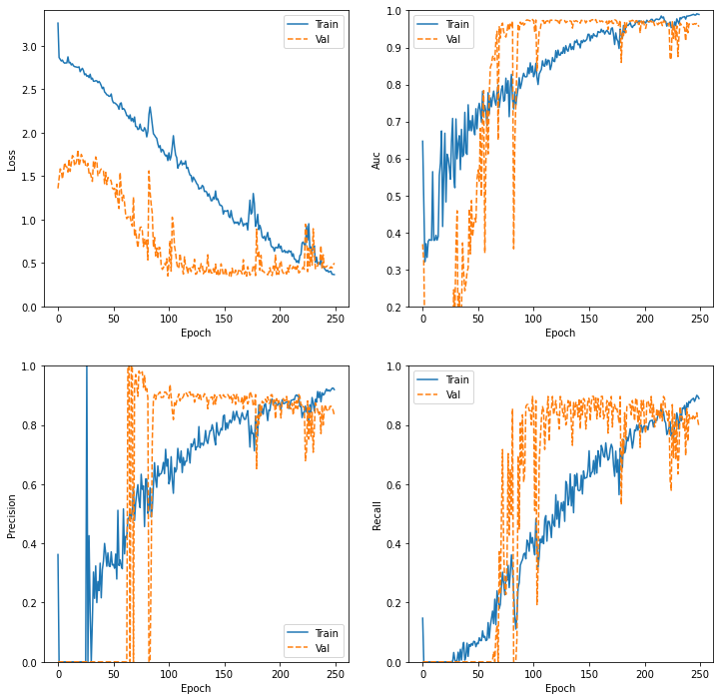

## K-FOLDS Transfer Learning mono

8249 segons = 2.30 hores

### FOLD-1

Confusion Matrix

[[49 4 1 5]

[ 5 5 0 1]

[ 1 2 2 1]

[ 7 1 0 24]]

Classification Report

precision recall f1-score support

0.0 0.79 0.83 0.81 59

0.33 0.42 0.45 0.43 11

0.66 0.67 0.33 0.44 6

1.0 0.77 0.75 0.76 32

accuracy 0.74 108

macro avg 0.66 0.59 0.61 108

weighted avg 0.74 0.74 0.74 108

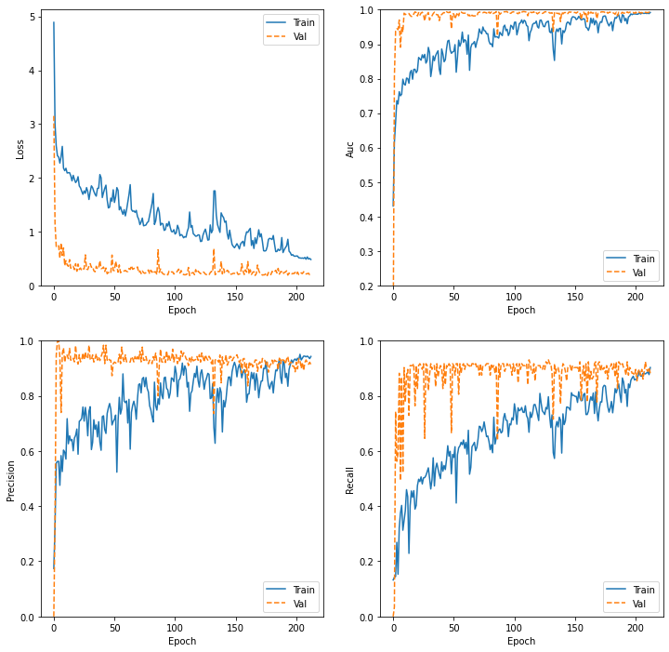

### FOLD-2

Confusion Matrix

[[48 3 2 5]

[ 2 9 1 0]

[ 3 0 3 0]

[10 2 0 20]]

Classification Report

precision recall f1-score support

0.0 0.76 0.83 0.79 58

0.33 0.64 0.75 0.69 12

0.66 0.50 0.50 0.50 6

1.0 0.80 0.62 0.70 32

accuracy 0.74 108

macro avg 0.68 0.68 0.67 108

weighted avg 0.75 0.74 0.74 108

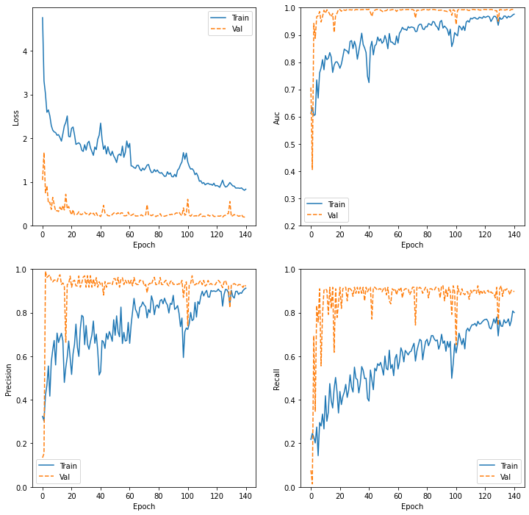

### FOLD-3

Confusion Matrix

[[53 2 1 2]

[ 4 6 2 0]

[ 3 1 2 0]

[ 3 1 2 26]]

Classification Report

precision recall f1-score support

0.0 0.84 0.91 0.88 58

0.33 0.60 0.50 0.55 12

0.66 0.29 0.33 0.31 6

1.0 0.93 0.81 0.87 32

accuracy 0.81 108

macro avg 0.66 0.64 0.65 108

weighted avg 0.81 0.81 0.80 108

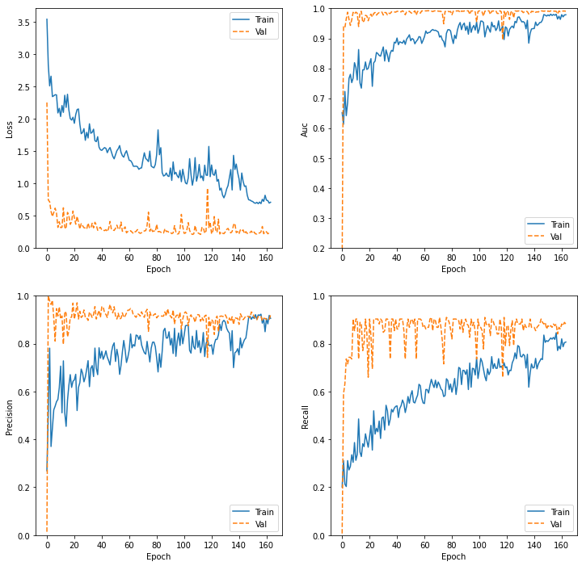

### FOLD-4

Confusion Matrix

[[40 6 4 9]

[ 4 5 1 2]

[ 5 0 1 0]

[ 2 0 3 26]]

Classification Report

precision recall f1-score support

0.0 0.78 0.68 0.73 59

0.33 0.45 0.42 0.43 12

0.66 0.11 0.17 0.13 6

1.0 0.70 0.84 0.76 31

accuracy 0.67 108

macro avg 0.51 0.53 0.52 108

weighted avg 0.69 0.67 0.67 108

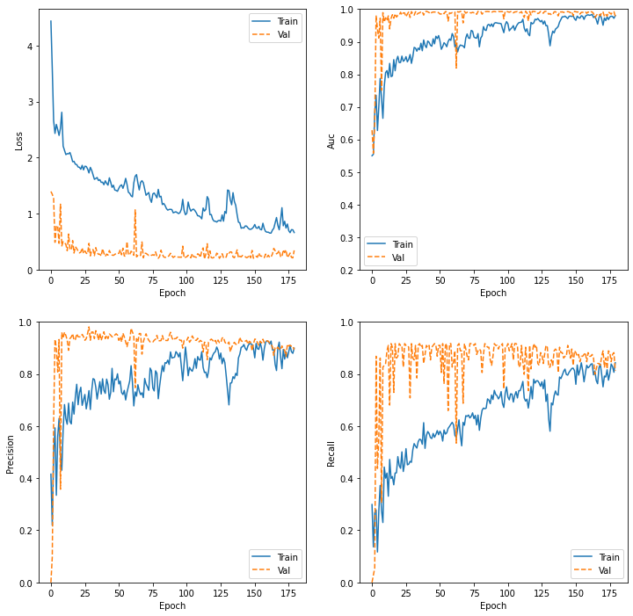

### FOLD-5

Confusion Matrix

[[55 4 0 0]

[ 5 7 0 0]

[ 3 1 1 0]

[10 1 0 20]]

Classification Report

precision recall f1-score support

0.0 0.75 0.93 0.83 59

0.33 0.54 0.58 0.56 12

0.66 1.00 0.20 0.33 5

1.0 1.00 0.65 0.78 31

accuracy 0.78 107

macro avg 0.82 0.59 0.63 107

weighted avg 0.81 0.78 0.77 107

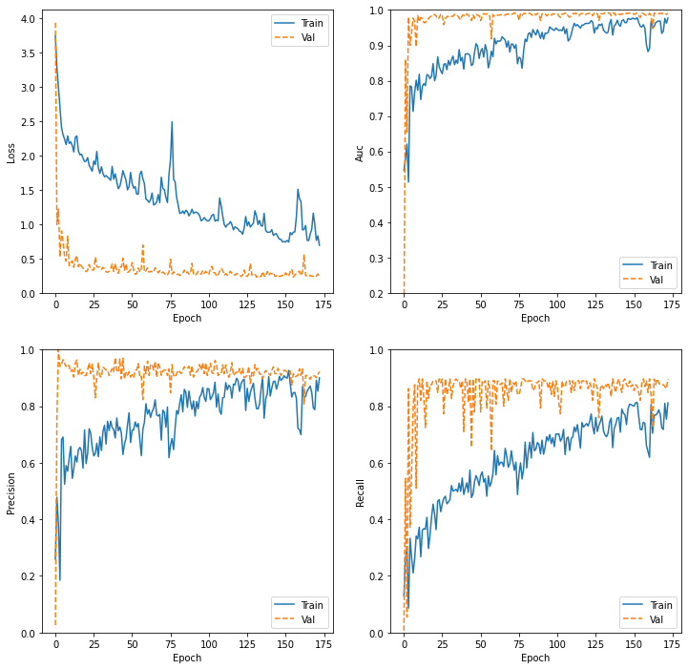

### FOLD-6

Confusion Matrix

[[52 1 3 3]

[ 5 6 1 0]

[ 0 2 3 0]

[ 5 1 2 23]]

Classification Report

precision recall f1-score support

0.0 0.84 0.88 0.86 59

0.33 0.60 0.50 0.55 12

0.66 0.33 0.60 0.43 5

1.0 0.88 0.74 0.81 31

accuracy 0.79 107

macro avg 0.66 0.68 0.66 107

weighted avg 0.80 0.79 0.79 107

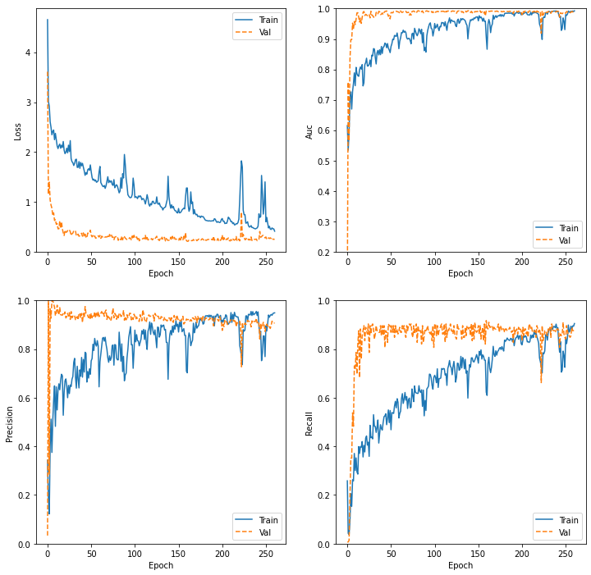

### FOLD-7

Confusion Matrix

[[45 6 5 3]

[ 5 5 2 0]

[ 4 1 0 0]

[ 7 0 7 17]]

Classification Report

precision recall f1-score support

0.0 0.74 0.76 0.75 59

0.33 0.42 0.42 0.42 12

0.66 0.00 0.00 0.00 5

1.0 0.85 0.55 0.67 31

accuracy 0.63 107

macro avg 0.50 0.43 0.46 107

weighted avg 0.70 0.63 0.65 107

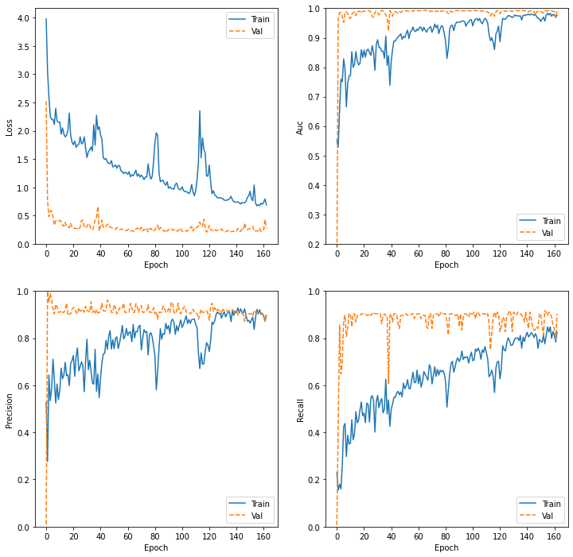

### FOLD-8

Confusion Matrix

[[51 1 1 6]

[ 5 6 1 0]

[ 3 1 1 0]

[ 5 0 0 26]]

Classification Report

precision recall f1-score support

0.0 0.80 0.86 0.83 59

0.33 0.75 0.50 0.60 12

0.66 0.33 0.20 0.25 5

1.0 0.81 0.84 0.83 31

accuracy 0.79 107

macro avg 0.67 0.60 0.63 107

weighted avg 0.77 0.79 0.78 107

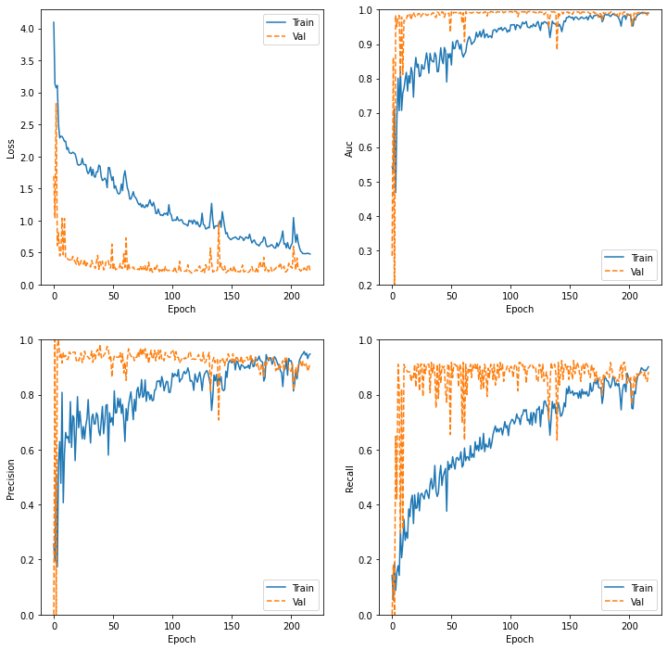

### FOLD-9

Confusion Matrix

[[51 3 3 2]

[ 6 4 0 1]

[ 4 1 1 0]

[ 6 1 3 21]]

Classification Report

precision recall f1-score support

0.0 0.76 0.86 0.81 59

0.33 0.44 0.36 0.40 11

0.66 0.14 0.17 0.15 6

1.0 0.88 0.68 0.76 31

accuracy 0.72 107

macro avg 0.56 0.52 0.53 107

weighted avg 0.73 0.72 0.72 107

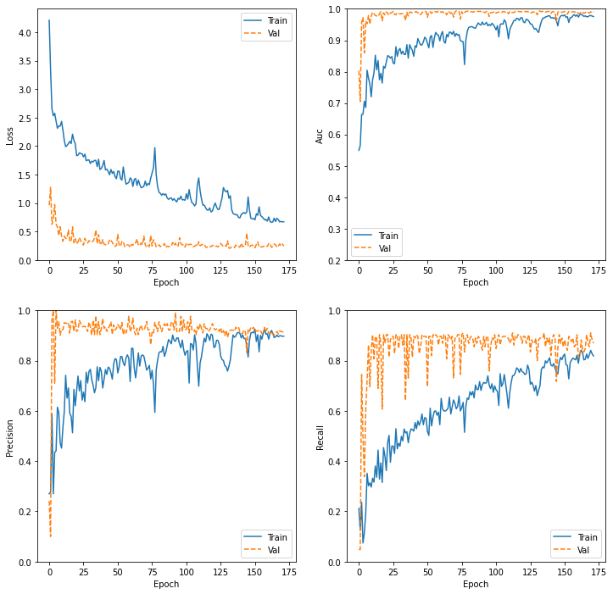

### FOLD-10

Confusion Matrix

[[52 2 5 0]

[ 2 3 6 0]

[ 1 1 4 0]

[ 4 1 2 24]]

Classification Report

precision recall f1-score support

0.0 0.88 0.88 0.88 59

0.33 0.43 0.27 0.33 11

0.66 0.24 0.67 0.35 6

1.0 1.00 0.77 0.87 31

accuracy 0.78 107

macro avg 0.64 0.65 0.61 107

weighted avg 0.83 0.78 0.79 107

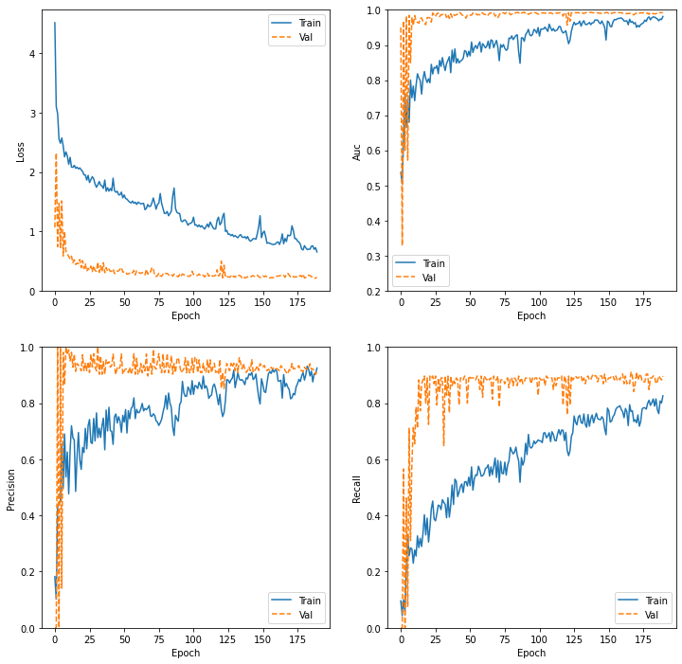

## K-FOLDS 4-capes mono

18551 segons = 5.15 hores

### FOLD-1

Confusion Matrix

[[30 11 9 9]

[ 2 5 3 1]

[ 1 1 3 1]

[ 5 2 2 23]]

Classification Report

precision recall f1-score support

0.0 0.79 0.51 0.62 59

0.33 0.26 0.45 0.33 11

0.66 0.18 0.50 0.26 6

1.0 0.68 0.72 0.70 32

accuracy 0.56 108

macro avg 0.48 0.55 0.48 108

weighted avg 0.67 0.56 0.59 108

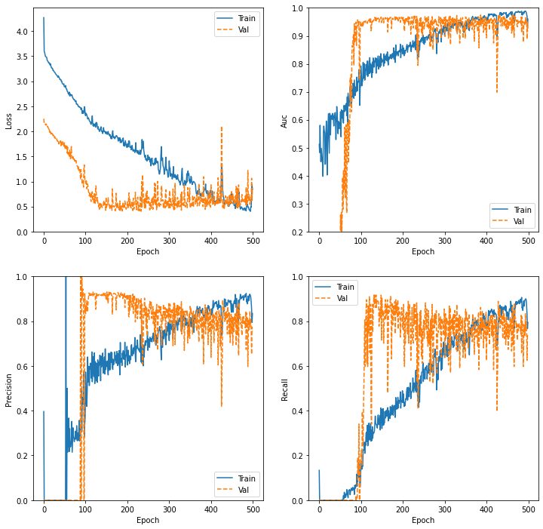

### FOLD-2

Confusion Matrix

[[34 9 8 7]

[ 3 7 2 0]

[ 1 0 4 1]

[ 7 3 1 21]]

Classification Report

precision recall f1-score support

0.0 0.76 0.59 0.66 58

0.33 0.37 0.58 0.45 12

0.66 0.27 0.67 0.38 6

1.0 0.72 0.66 0.69 32

accuracy 0.61 108

macro avg 0.53 0.62 0.55 108

weighted avg 0.68 0.61 0.63 108

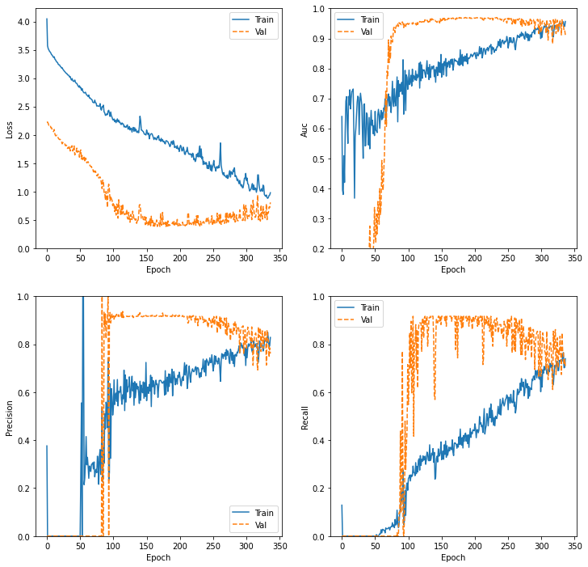

### FOLD-3

Confusion Matrix

[[39 10 2 7]

[ 1 7 2 2]

[ 2 1 3 0]

[ 4 2 2 24]]

Classification Report

precision recall f1-score support

0.0 0.85 0.67 0.75 58

0.33 0.35 0.58 0.44 12

0.66 0.33 0.50 0.40 6

1.0 0.73 0.75 0.74 32

accuracy 0.68 108

macro avg 0.56 0.63 0.58 108

weighted avg 0.73 0.68 0.69 108

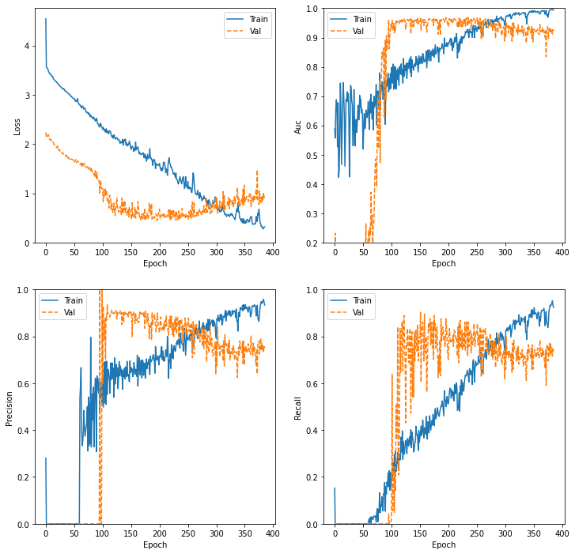

### FOLD-4

Confusion Matrix

[[39 8 5 7]

[ 5 6 1 0]

[ 4 0 1 1]

[ 3 0 3 25]]

Classification Report

precision recall f1-score support

0.0 0.76 0.66 0.71 59

0.33 0.43 0.50 0.46 12

0.66 0.10 0.17 0.12 6

1.0 0.76 0.81 0.78 31

accuracy 0.66 108

macro avg 0.51 0.53 0.52 108

weighted avg 0.69 0.66 0.67 108

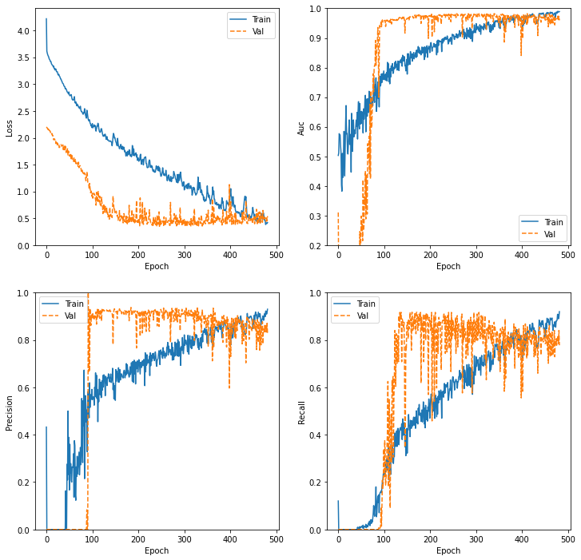

### FOLD-5

Confusion Matrix

[[47 6 2 4]

[ 5 6 1 0]

[ 3 2 0 0]

[ 6 0 2 23]]

Classification Report

precision recall f1-score support

0.0 0.77 0.80 0.78 59

0.33 0.43 0.50 0.46 12

0.66 0.00 0.00 0.00 5

1.0 0.85 0.74 0.79 31

accuracy 0.71 107

macro avg 0.51 0.51 0.51 107

weighted avg 0.72 0.71 0.71 107

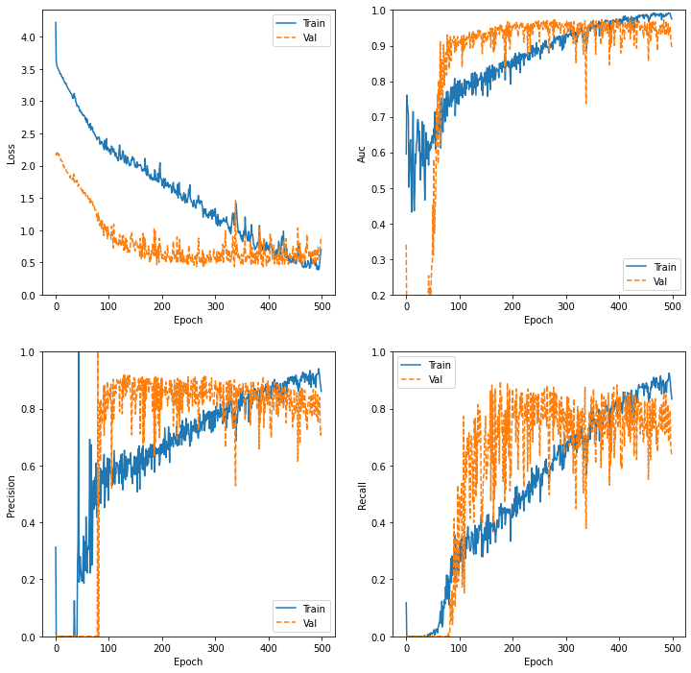

### FOLD-6

Confusion Matrix

[[35 12 6 6]

[ 2 9 1 0]

[ 0 3 2 0]

[ 4 1 2 24]]

Classification Report

precision recall f1-score support

0.0 0.85 0.59 0.70 59

0.33 0.36 0.75 0.49 12

0.66 0.18 0.40 0.25 5

1.0 0.80 0.77 0.79 31

accuracy 0.65 107

macro avg 0.55 0.63 0.56 107

weighted avg 0.75 0.65 0.68 107

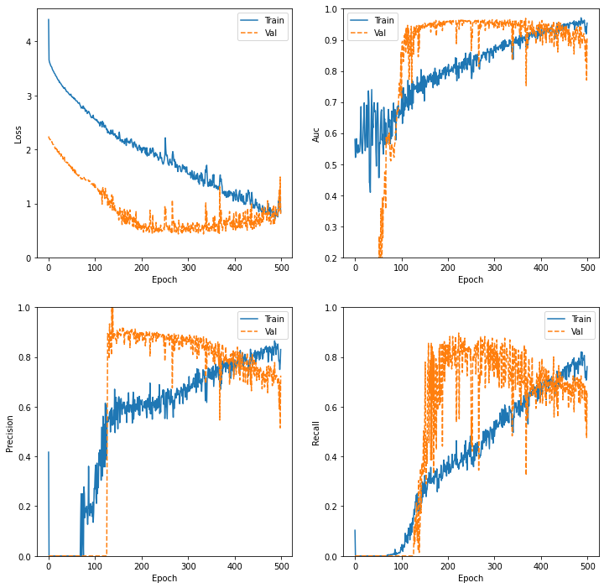

### FOLD-7

Confusion Matrix

[[24 6 19 10]

[ 4 3 3 2]

[ 1 1 0 3]

[ 8 2 2 19]]

Classification Report

precision recall f1-score support

0.0 0.65 0.41 0.50 59

0.33 0.25 0.25 0.25 12

0.66 0.00 0.00 0.00 5

1.0 0.56 0.61 0.58 31

accuracy 0.43 107

macro avg 0.36 0.32 0.33 107

weighted avg 0.55 0.43 0.47 107

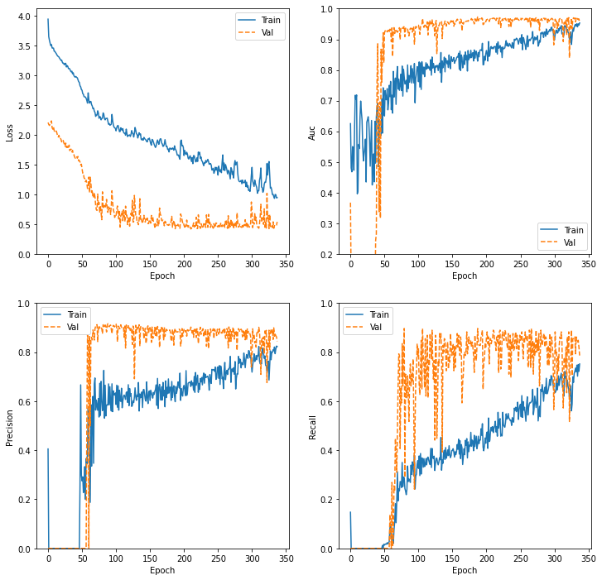

### FOLD-8

Confusion Matrix

[[30 11 6 12]

[ 2 7 2 1]

[ 1 1 2 1]

[ 3 2 2 24]]

Classification Report

precision recall f1-score support

0.0 0.83 0.51 0.63 59

0.33 0.33 0.58 0.42 12

0.66 0.17 0.40 0.24 5

1.0 0.63 0.77 0.70 31

accuracy 0.59 107

macro avg 0.49 0.57 0.50 107

weighted avg 0.69 0.59 0.61 107

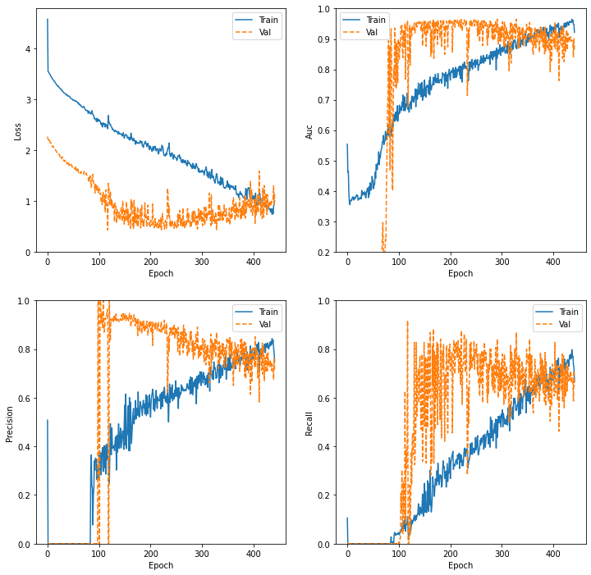

### FOLD-9

Confusion Matrix

[[48 7 2 2]

[ 5 5 0 1]

[ 3 1 1 1]

[ 7 1 0 23]]

Classification Report

precision recall f1-score support

0.0 0.76 0.81 0.79 59

0.33 0.36 0.45 0.40 11

0.66 0.33 0.17 0.22 6

1.0 0.85 0.74 0.79 31

accuracy 0.72 107

macro avg 0.58 0.54 0.55 107

weighted avg 0.72 0.72 0.72 107

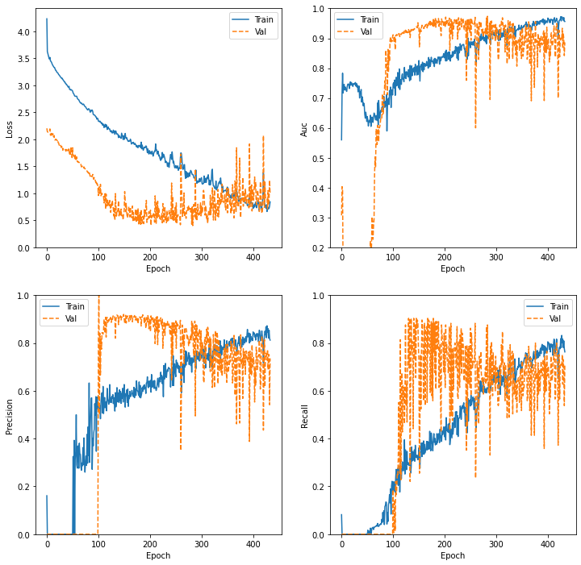

### FOLD-10

Confusion Matrix

[[33 2 16 8]

[ 4 3 3 1]

[ 0 1 2 3]

[ 1 1 2 27]]

Classification Report

precision recall f1-score support

0.0 0.87 0.56 0.68 59

0.33 0.43 0.27 0.33 11

0.66 0.09 0.33 0.14 6

1.0 0.69 0.87 0.77 31

accuracy 0.61 107

macro avg 0.52 0.51 0.48 107

weighted avg 0.73 0.61 0.64 107

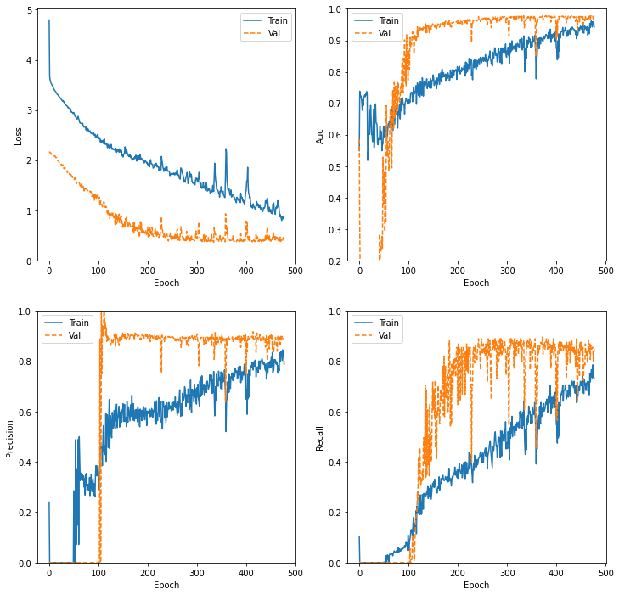

## K-FOLDS Transfer POLY

### FOLD-1

Confusion Matrix

[[84 2 1 5]

[10 6 0 1]

[ 3 1 1 0]

[12 2 0 27]]

Classification Report

precision recall f1-score support

0.0 0.77 0.91 0.84 92

0.33 0.55 0.35 0.43 17

0.66 0.50 0.20 0.29 5

1.0 0.82 0.66 0.73 41

accuracy 0.76 155

macro avg 0.66 0.53 0.57 155

weighted avg 0.75 0.76 0.75 155

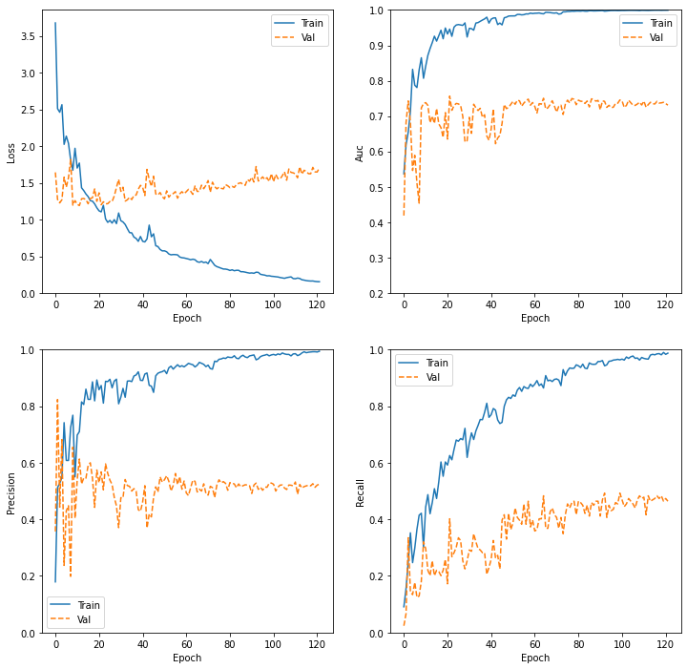

### FOLD-2

Confusion Matrix

[[78 6 0 8]

[ 5 11 0 1]

[ 3 1 0 1]

[13 0 0 28]]

Classification Report

precision recall f1-score support

0.0 0.79 0.85 0.82 92

0.33 0.61 0.65 0.63 17

0.66 0.00 0.00 0.00 5

1.0 0.74 0.68 0.71 41

accuracy 0.75 155

macro avg 0.53 0.54 0.54 155

weighted avg 0.73 0.75 0.74 155

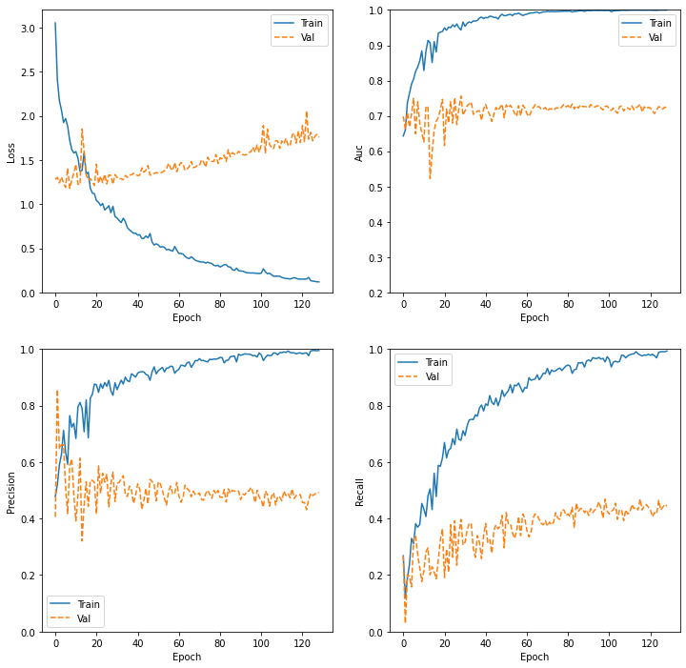

### FOLD-3

Confusion Matrix

[[81 5 0 6]

[12 5 0 1]

[ 3 0 0 2]

[19 0 0 21]]

Classification Report

precision recall f1-score support

0.0 0.70 0.88 0.78 92

0.33 0.50 0.28 0.36 18

0.66 0.00 0.00 0.00 5

1.0 0.70 0.53 0.60 40

accuracy 0.69 155

macro avg 0.48 0.42 0.43 155

weighted avg 0.66 0.69 0.66 155

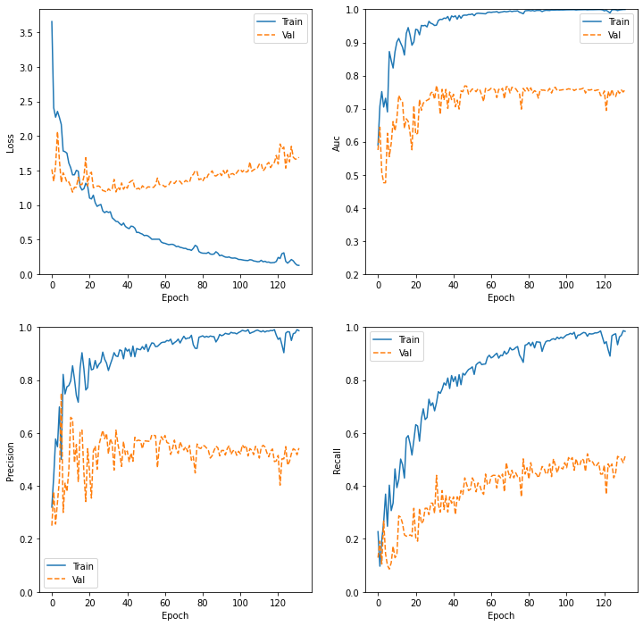

### FOLD-4

Confusion Matrix

[[79 3 0 10]

[14 3 0 1]

[ 2 0 0 3]

[18 0 1 21]]

Classification Report

precision recall f1-score support

0.0 0.70 0.86 0.77 92

0.33 0.50 0.17 0.25 18

0.66 0.00 0.00 0.00 5

1.0 0.60 0.53 0.56 40

accuracy 0.66 155

macro avg 0.45 0.39 0.40 155

weighted avg 0.63 0.66 0.63 155

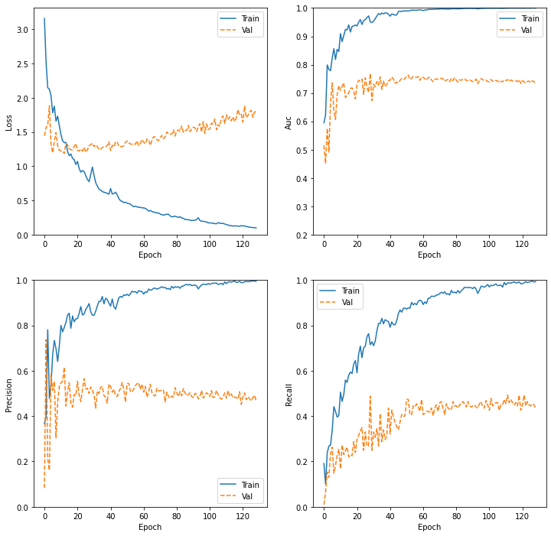

### FOLD-5

Confusion Matrix

[[77 4 0 11]

[ 7 6 0 5]

[ 4 0 0 1]

[ 9 0 0 31]]

Classification Report

precision recall f1-score support

0.0 0.79 0.84 0.81 92

0.33 0.60 0.33 0.43 18

0.66 0.00 0.00 0.00 5

1.0 0.65 0.78 0.70 40

accuracy 0.74 155

macro avg 0.51 0.49 0.49 155

weighted avg 0.71 0.74 0.72 155

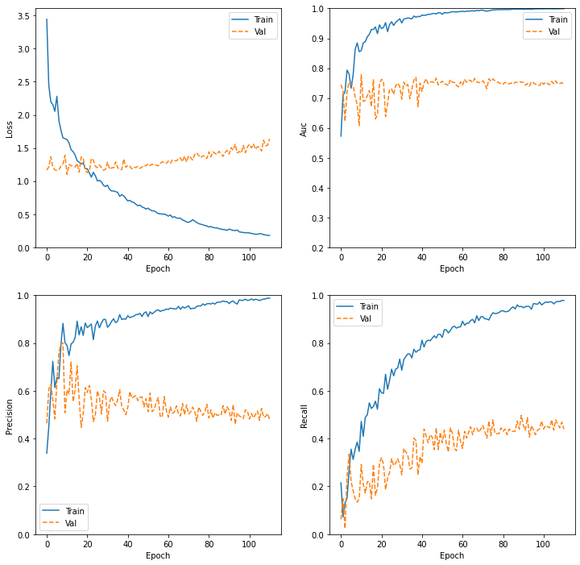

### FOLD-6

Confusion Matrix

[[78 2 2 10]

[ 5 10 0 3]

[ 2 0 0 3]

[ 9 0 0 31]]

Classification Report

precision recall f1-score support

0.0 0.83 0.85 0.84 92

0.33 0.83 0.56 0.67 18

0.66 0.00 0.00 0.00 5

1.0 0.66 0.78 0.71 40

accuracy 0.77 155

macro avg 0.58 0.54 0.55 155

weighted avg 0.76 0.77 0.76 155

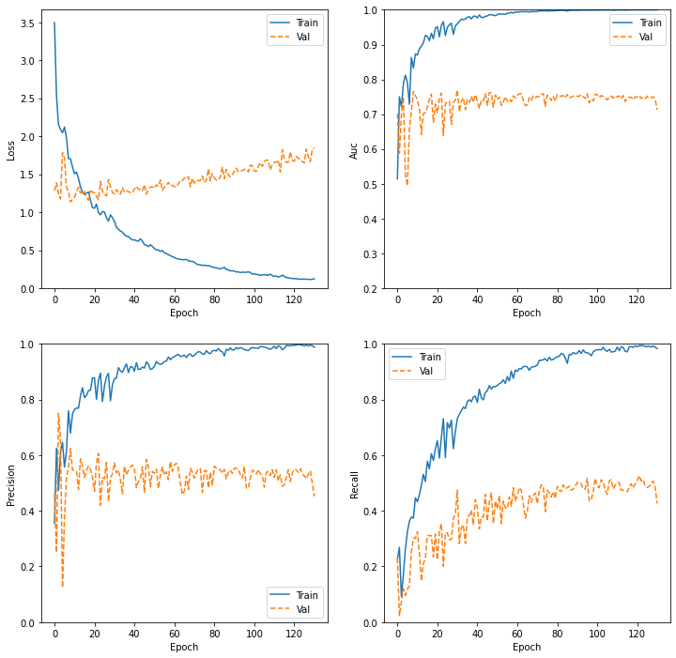

### FOLD-7

Confusion Matrix

[[78 6 0 8]

[11 6 0 1]

[ 4 1 0 0]

[11 1 1 27]]

Classification Report

precision recall f1-score support

0.0 0.75 0.85 0.80 92

0.33 0.43 0.33 0.38 18

0.66 0.00 0.00 0.00 5

1.0 0.75 0.68 0.71 40

accuracy 0.72 155

macro avg 0.48 0.46 0.47 155

weighted avg 0.69 0.72 0.70 155

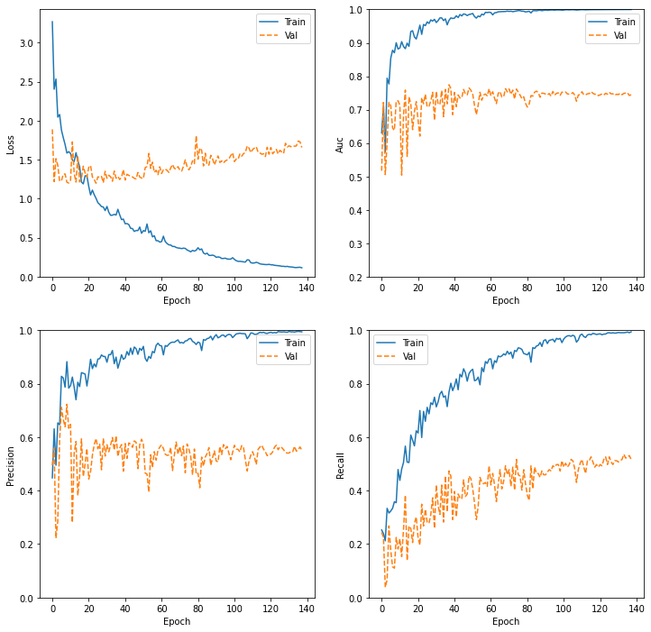

### FOLD-8

Confusion Matrix

[[70 5 1 16]

[ 8 7 0 3]

[ 2 0 0 3]

[ 7 0 0 33]]

Classification Report

precision recall f1-score support

0.0 0.80 0.76 0.78 92

0.33 0.58 0.39 0.47 18

0.66 0.00 0.00 0.00 5

1.0 0.60 0.82 0.69 40

accuracy 0.71 155

macro avg 0.50 0.49 0.49 155

weighted avg 0.70 0.71 0.70 155

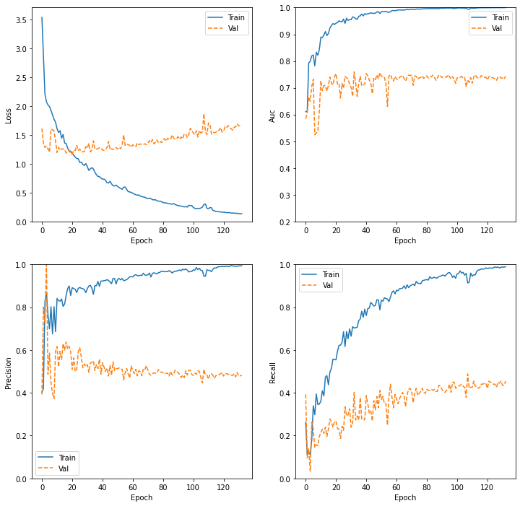

### FOLD-9

Confusion Matrix

[[70 5 1 16]

[ 8 7 0 3]

[ 2 0 0 3]

[ 7 0 0 33]]

Classification Report

precision recall f1-score support

0.0 0.80 0.76 0.78 92

0.33 0.58 0.39 0.47 18

0.66 0.00 0.00 0.00 5

1.0 0.60 0.82 0.69 40

accuracy 0.71 155

macro avg 0.50 0.49 0.49 155

weighted avg 0.70 0.71 0.70 155

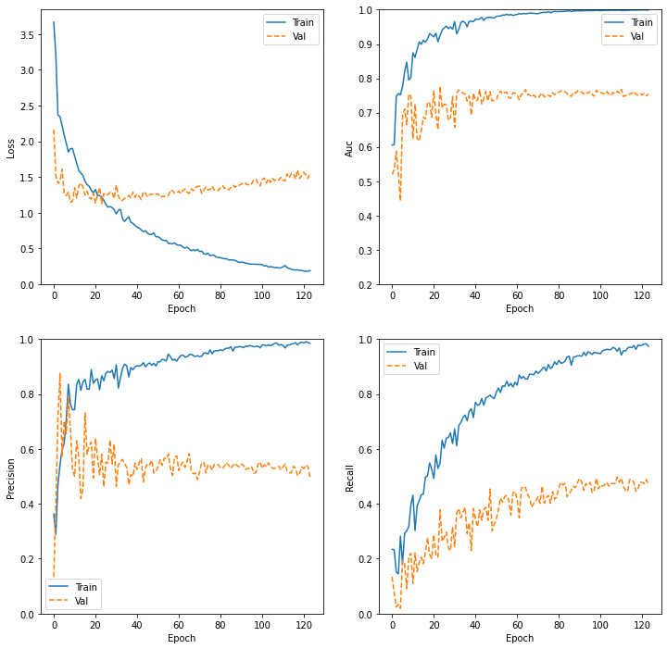

### FOLD-10

Confusion Matrix

[[68 2 0 22]

[ 9 6 0 3]

[ 5 0 0 0]

[10 1 0 29]]

Classification Report

precision recall f1-score support

0.0 0.74 0.74 0.74 92

0.33 0.67 0.33 0.44 18

0.66 0.00 0.00 0.00 5

1.0 0.54 0.72 0.62 40

accuracy 0.66 155

macro avg 0.49 0.45 0.45 155

weighted avg 0.65 0.66 0.65 155

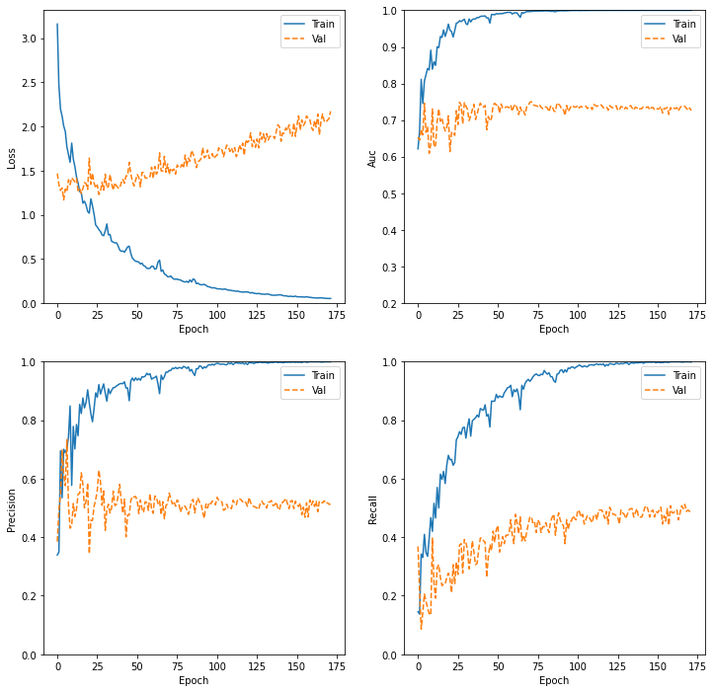

**Cal posar un L2 de 0.1!! i potser dropout?**